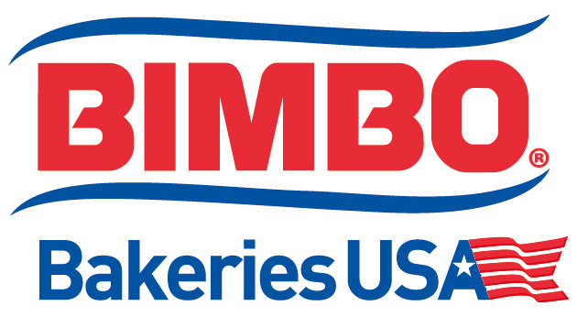

Controls Technician
BASIC PURPOSE/SCOPE:
We are seeking a self-motivated candidate to provide controls support to a highly automated and fast paced baking facility. The qualified candidate should have strong problem solving and trouble shooting skills with a strong background in industrial controls. The position will require experience with the latest versions of the Allen Bradley family of PLC’s, VFD’s and HMI’s to be used in conjunction with a strong understanding of electrical controls systems, mechanical drives, pneumatics, hydraulics, PC’s, robotics, and Ethernet networks.
PRINCIPLE ACCOUNTABILITES:
  - Provide expertise using RSLogix 5000, Factory Talk Studio, and other Rockwell Automation software packages
  - Review key plant metrics and data to identify potential areas for improvement then lead a team to develop an engineered solution
  - Provide second level break down support to the maintenance department
  - Lead root cause problem solving sessions to review specific pieces of the process with the goal of eliminating waste and downtime to meet all production team goals
  - Provide support for the manufacturing Ethernet network and act as a liaison between plant personnel and corporate IT
  - Manage Rockwell Automation software on department PC’s
  - Supports without hesitation General Plant Safety, Food Safety, Food Defense Initiatives and Good Manufacturing Practices with an understanding that these are absolutes & are Priority #1.
  - Assures that General Safety and Food Safety is an absolute priority by setting the example as a member of senior management.
  - Work closely with production supervisors to provide effective controls support
  - Promote a strong teamwork environment
  - Ensure equipment in area is maintained, guarded and operated in accordance with defined safety regulations and procedures
  - Understand levels of scrap and rework in area caused by equipment issues and associated points of cause
  - Identify potential cost savings and cost avoidance
  - Participate in budget planning for area and department
JOB REQUIRMENTS:
  - Technical degree in a related field or equivalent experience
  - Strong experience with the following software packages
    - RSLogix 5000
    - Factory Talk Studio
    - RSLinx
    - Connected Components Work Bench
    - AutoCad (Preferred)
    - Microsoft Office
  - Strong overall electrical knowledge and experience with control systems is a must
  - Excellent communication skills and effective team building skills a must
Experience in a food processing plant is preferred.
BBU is an Equal Employment Opportunity Employer – M/F/D/V

