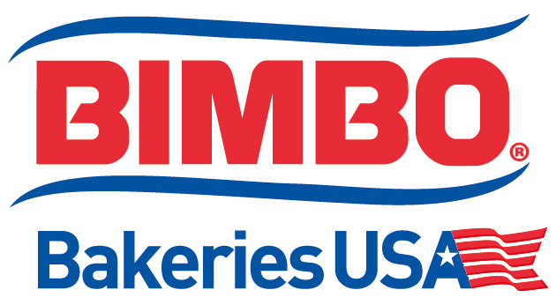

ASSISTANT CHIEF ENGINEER
BASIC PURPOSE/SCOPE:
Proactively, and predicatively creates, develops and implements plans and procedures to motivate, direct, and manage engineering / maintenance associates to complete work orders, preventive maintenance procedures, overhaul procedures and other assignments to ensure food safety, employee safety, product quality, and environmental compliance.
Responsible for ensuring the best quality products, excellent customer service by maintaining regular quality audits (AIB), good manufacturing practices, compliance with federal/state/local regulations (FDA, OSHA, Department of Agriculture, Department of Health, etc.), HACCP, meet or exceed Global Food Safety Standards (BRC), environmental compliance, and DOT mandates.
PRINCIPAL ACCOUNTABILITIES:
  - Supports General Plant Safety, Food Safety, Food Defense initiatives and Good Manufacturing Practices with an understanding that these are absolutes and are Priority #1. Ensuring that General safety and Food Safety are absolute priorities by setting an example to others.
  - Ensures that Product Quality is an absolute priority by utilizing internal programs, plant teams, and outside resources.
  - Develops, plans, and implements preventative and predictive work required to ensure the reliable operational performance of bakery equipment and processes. Notifies supervision of any equipment problems and makes recommendations for corrective action.
  - Responsible for training engineering, maintenance and contractor personnel on Lock-Out / Tag-Out, Confined Space, Hazard Material Handling and Personal Protective Equipment to provide technical support related to FDA (food security), OSHA, and EPA compliance
  - Provides leadership, trains, coaches and develops manufacturing management to include responsibility for personnel and/or labor issues throughout the plant.
  - Responsible for creating and managing an engineering / maintenance budget. Manages an annual capital budget program to company policies and standards.
  - Ensures that maintenance procedures are completed in line with company policies and standards.
  - Communicates the status of engineering / maintenance activities to personnel within operations.
  - Collaborates with production management to ensure optimal key performance indicator results.
EDUCATION:
Bachelor of Science Degree in Engineering or related field. A combination of education, training and experience that results in demonstrated competency to perform the work may be substituted.
EXPERIENCE:
  - Seven years or more experience related to predictive/proactive maintenance.
  - 3-5 Years supervisory experience.
  - A combination of education, training, and experience that results in demonstrated competency to perform the work may be substituted.
Reasonable accommodation may be made for those who are able to perform the essential duties of the job.
SPECIALIZED SKILLS AND KNOWLEDGE (This section would allow for you to detail special requirements for the position in the particular market/plant/region, if necessary.)
  - Electro/mechanical, hydraulics and pneumatics system design and troubleshooting knowledge.
  - Capable of teaching, training and sharing technical knowledge to employees within operations.
  - Knowledge of Bakery equipment and process.
  - Knowledge of Programmable Logic Controller related to both programming and troubleshooting.

